

Clerks: Miss B Macklen & Mrs C Feltham, PO Box 202, Heathfield, East Sussex TN21 1BN
e: clerk@buxted-pc.gov.uk w:buxtedparishcouncil.gov.uk

15th November 2023

MINUTES
BUXTED PARISH COUNCIL PLANNING COMMITTEE 14th NOVEMBER 2023

Members present: Cllr Smith (Vice Chair), Cllr Blandford, Cllr Humphrey, Cllr Rose and Cllr Coxon.
Also present: Claudine Feltham & Beccy Macklen (Clerks).
There were 21 members of the public present.

Eight members of the public spoke in connection with their significant objections to agenda item 4.3 (WD/2023/2157/MAJ LAND NORTH OF THE A272, BUXTED, TN22 4BA).
The main concerns included: flooding of the A272, flooding of nearby Grade I and II listed homes that have already been subject to flooding in recent times, additional flooding of gardens close to the site, road safety, safety to pedestrians walking alongside A272 (including children walking to school), overdevelopment of the area, concern to water courses, additional water going into River Uck which could cause flooding in other areas, continued maintenance of drains after the developers 5 year initial requirement, inaccuracies in the submitted documents supporting the application, momentous historical interest, crucial heritage assets, dangerous environmental concerns, capacity at schools and doctors.

WDC Cllr Shaw advised parishioners: that whilst there was a deadline of for responses on the WDC website, he would encourage members to continue to submit their responses, even after this deadline. It is likely that this will be going to Planning Committee North – and this would not be before February 2024. WDC Cllr Shaw welcomed parishioners to send their comments and concerns to him about this application.

A parishioner spoke in connection with their continued efforts in objecting to planning application for 60 dwellings at LAND AT MOCKBEGGARS FARM, LONDON ROAD, UCKFIELD TN22 2EA, and hoped that the parish council would support the objection.

1.  2.  3. | Apologies for absence.  Apologies were received and accepted from Cllr Wilson, Cllr Marshall, Cllr Duck and Cllr Roberts  To approve the minutes of the previous meeting  The minutes of 10th October 2023 were approved and signed.  Declaration of Members personal and prejudicial Interests in respect of items on this agenda.  Cllr Rose declared a personal interest in respect of agenda item 4.3.
4.  4.1  4.2  4.3  4.4  4.5 | Planning Applications  Application: WD/2023/2512/RM  Link to documents on web: https://planning.wealden.gov.uk/plandisp.aspx?recno=163588  Expiry date for comments: 8 November 2023 extension granted to 15.11.23)  Location: SAXON COURT, POUND GREEN, BUXTED, TN22 4DT  Description: reserved matters (access, appearance, landscaping, layout and scale) pursuant to outline permission WD/2019/1335/O (outline application for the erection of 2 no. houses, alterations to access road and part demolition of redundant care home buildings, e.g., laundry, shed).  Buxted Parish Council response to WDC: no objection  Application: WD/2023/2513/LDE  Expiry date for comments: 18th October (extension granted to 15.11.23)  Location: LAND AT MILLWOOD LANE, FIVE ASH DOWN, UCKFIELD, TN22 3AU  Description: confirmation of commencement of planning permission WD/2018/0259/F (erection of 1 no. dwelling, access, landscaping and associated infrastructure)  Buxted Parish Council response to WDC: members considered this application and object.  Members of the parish council understand that conditions 4 and 6 of the planning permission have not been met ('before preparation of any groundworks and foundations on site for the development hereby approved’) and therefore the original planning approval has expired and would require a new application to be submitted for consideration.  Application: WD/2023/2157/MAJ  Link to documents on web: https://planning.wealden.gov.uk/plandisp.aspx?recno=163172  Expiry date for comments: 10th November 2023 (extension granted to 15.11.23)  Location: LAND NORTH OF THE A272, BUXTED, TN22 4BA  Description: erection of up to 49 no. dwellings, access, landscaping and associated infrastructure  Buxted Parish Council response to WDC: OBJECT. Please see Appendix A.  Application: WD/2023/2534/PO  Link to documents on web: https://planning.wealden.gov.uk/plandisp.aspx?recno=163613  Expiry date for comments:10 November 2023 (extension granted to 15.11.23)  Location: LAND AT FORMER POUND GREEN NURSERIES, POUND GREEN, BUXTED  Description: variation of section 106 agreement dated 21 March 2023 attached to planning permission WD/2021/2766/F to vary paragraph 2 of schedule 1 to read 'first occupation' instead of 'commencement of development'  Buxted Parish Council response to WDC: no objection  Application: WD/2023/2425/F  Link to documents on web: https://planning.wealden.gov.uk/plandisp.aspx?recno=163486  Expiry date for comments: 13 November 2023  Location: BUDLETTS MANOR, BUDLETTS LANE, COOPERS GREEN, UCKFIELD, TN22 3AE  Description: construction of two storey detached dwelling with garage.  Buxted Parish Council response to WDC: Members noted on the previous application for this site that the traffic survey was completed during lock down and would therefore not reflect true results. The same survey has been submitted for this application, and so remains irrelevant.  The parish council object to this application and request a revised survey.
4.6  4.7  4.8  4.9  5. | Application: WD/2023/2651/FA  Link to documents on web: https://planning.wealden.gov.uk/plandisp.aspx?recno=163762  Expiry date for comments: 22nd November 2023  Location: TEMPLE GROVE, UNIT 7, UCKFIELD ROAD, HERONS GHYLL, TN22 4BY  Description: variation of conditions 2, 3, 6. 7. 8, 9, 11, 12 AND 17OF WD/2020/2230/F demolition of existing medical centre building. Residential development for the erection of two detached dwellings, associated garages and parking. Provision of a new internal vehicular access and landscaping.  Buxted Parish Council response to WDC: no objection.  Application: WD/2023/2558/F  Link to documents on web: https://planning.wealden.gov.uk/plandisp.aspx?recno=163640  Expiry date for comments: 23rd November 2023  Location: HILLSIDE, FRAMFIELD ROAD, BUXTED, TN22 4PG  Description: single storey rear extension  Buxted Parish Council response to WDC: no objection.  Application: WD/2023/2666/F  Link to documents on web: https://planning.wealden.gov.uk/plandisp.aspx?recno=163777  Expiry date for comments: 23rd November 2023  Location: MOORINGS, HIGH STREET, BUXTED, TN22 4JU  Description: creation of new vehicular access onto High Street  Buxted Parish Council response to WDC: we are confused with this application as we believed that the extra entrance was already approved (in the previously approved application) for this site. Members of the planning committee would respectfully request for the Case Officer to provide additional information and explanation so that the planning committee can consider this application at our next meeting on 12th December 2023.  Application: WD/2023/2122/F  Link to documents on web: https://planning.wealden.gov.uk/plandisp.aspx?recno=163125  Expiry date for comments: 20th November 2023  Location: MALUS, CHURCH ROAD, BUXTED, TN22 4LT  Description: porch on front elevation of dwelling. Detached garage.  Buxted Parish Council response to WDC: members considered this application, and their objections still stand.
Applications considered by email due to the deadline set by WDC.

Applications determined/updated by Wealden District Council

Application No. WD/2023/1527/F
Description: replacement dwelling
Location: HIGHFIELD, ROCKS LANE, HIGH HURSTWOOD, BUXTED, TN22 4BN
Decision: Withdrawn

Application No. WD/2023/2084/FR
Description: part retrospective application for the demolition of part of existing unauthorised balcony to create an access platform to accommodate newly installed bi-fold doors
Location: NEW FARMHOUSE, STOCKLANDS LANE, HADLOW DOWN, TN22 4EA
Decision: Approved

Application No. WD/2023/2120/FA
Description: variation of condition 14 of WD/2022/1932/F (erection of 1 no. New detached dwelling). Submit revised floor plans and elevations to incorporate a balcony to front elevation and change external finishes to render and tile hanging. Removal of chimney and reorganisation of window openings.
Location: MILESTONES, LONDON ROAD, BUDLETTS COMMON, UCKFIELD, TN22 2EB
Decision: Approved

Application No. WD/2023/2059/F
Description: replacement of timber balcony with glass and spiral staircase and extension of hardstanding area to the east of the garden for additional parking.
Location: REDBROOK COTTAGE, REDBROOK LANE, BUXTED, TN22 4QH
Decision: Approved

Application No. WD/2022/2960/F
Description: demolition of existing dwelling and phased development of two self-build dwellings including new vehicular access at Tudor Views, Coopers Green Road. Phase 1 being the demolition of the existing garage and construction of new access to plot 2, phase 2 being the construction of both dwellings and garages, phase 3 being the demolition of the existing dwelling.
Location: Tudor Views, Coopers Green Road, Uckfield, TN22 1HB
Comment from WDC to BPC: While accepting the buildings are in front of the existing dwelling (to be demolished), it is noted there is no formal building line along the road, and there is also a variance of designs and style. The materials proposed are traditional materials, albeit arranged in a more contemporary style, and a materials condition would ensure the LPA can have influence over the finished materials and ensure they are acceptable in the street scene. Drainage issues can also be covered by condition to ensure a workable drainage scheme is implemented.
Decision: Approved

Application No. WD/2023/2287/F
Description: rear ground floor extension with two rooflights - loft conversion with front and rear dormers - removal of flat roof at front of property and replacing with pitched roof
Location: TAHILLA, HIGH STREET, BUXTED, TN22 4JU
Decision: Approved

Application No. WD/2023/1931/F
Description: ADDITION OF 2M HIGH CLOSE BOARDED FENCE AND PEDESTRIAN GATE ON THE ROADSIDE BOUNDARY
Location: DIAMOND COTTAGE, LONDON ROAD, BUDLETTS COMMON, UCKFIELD, TN22 2EA
Withdrawn

Application No. WD/2023/2288/LDE
Description: use as a dwelling without complying with the condition (agricultural occupancy) attached to planning permission T/52/8633/4C
Location: TOLL FARM COTTAGE, POUND GREEN, BUXTED, TN22 4PJ
Decision: issued.

Appeals/Enforcement

Town and Country Planning Act 1990
Appeal by Obsidian Strategic Asset Management Ltd (the Appellant)
Planning Inspectorate ref: APP/C1435/W/23/3330872
Site: LAND AT MOCKBEGGARS FARM, LONDON ROAD, UCKFIELD TN22 2EA
Proposal: outline application for the development of 60 no. Dwellings, access and internal roads, parking, ancillary structures, landscaping and open space, drainage and other associated works. All matters reserved apart from access.
Notes: ‘Any views received in writing by the Council at the application stage will have been forwarded to The Planning Inspectorate, for the Inspector’s attention.
representations can be made in writing (please enclose THREE copies of your representations) and sent direct to The Planning Inspectorate at the address overleaf, quoting APP/C1435/W/23/3330872. The Planning Inspectorate will not acknowledge your letter.
Please ensure that any representations which you wish to make on this appeal are submitted to The Planning Inspectorate by 30 November 2023 otherwise they will not be considered and will be returned to you. You should note that for your views to be considered they must be made available to the Appellant, the District Council and the Secretary of State or his/her Inspector, accordingly such arrangements will be made. Details of the planning application and appeal can be viewed on-line on the Council’s website: www.planning.wealden.gov.uk. An electronic copy can also be viewed (on the Internet) at the Council Offices in Vicarage Lane, Hailsham, BN27 2AX by prior arrangement by telephoning 01892 602510’.

All members strongly object to this application and request for the following objection to be reiterated to WDC and The Planning Inspectorate:

Buxted Parish Council response to WDC: OBJECT.
Members considered the neighbours strong objections to this application. The changes made to the plans would lead to over development of upper part of the site. It is on a ridge which will be very visible in the landscape. The proposal to remove existing residents parking spaces outside the Ringles Cross Cottages is unacceptable, they have been parking there for at least 32 years. The mitigation aspects do not outweigh the harm to ancient woodlands and wildlife corridors and more recent bat surveys which have confirmed the presence of Barbastelle bats, amongst others. There are still considerable hydrological implications which do not seem to have been addressed and were queried in the original response from Buxted parish council and many others. The parish councils’ previous objections stand:

‘The parish council OBJECT to this application. Additional Historic Landscape Assessment not covered in the submitted application. Impact on Historic Landscape north‐east of Uckfield Early references This small enclosed and somewhat hidden landscape was once part of a wider landscape, some of which still exists to the east of the A22, now called Budletts Common, of which this was once part. The first found refence to Budletts Common was in 1585[1] and there is some historical reference to the common previously being called St Bartholomew’s Common which would mean it was connected to St Bartholomew’s Church in Maresfield and now is but a small extant part of a much wider landscape. There is reference to a lease dated to 1670 which refers to a tenement called Mockbeggars with outhouses, gardens and lands which is the earliest reference found to a property on this land [2] . Map Evidence On the 1778 Yeakell and Gardner map, the notable triangular shape of the land is depicted clearly with Malling Budletts Common land extending eastwards to the Ringles Cross Road and beyond, fronting the northern and north [1]eastern aspects of Views Wood (Ancient Woodland). A road dissects the lower part of the triangle, southwards to Ringles Cross and northwards, across the common and continuing through Five Ash Down. This road formed the old Uckfield/Buxted Parish boundary. On an 1812 Figg Map, drawn up for the owner of Buxted Park Estate, part of this land is noted as Malling Budletts. [3] This map shows a small rectangular, occupied building, on the opposite side of the road to the present farmhouse. This is likely to be the building which was standing in the mid C17 but was built over mid C20 by pigsties and likely to have been superseded by the early C19 farmhouse. C19‐C21 Development Mockbeggars Farm was once of the Buxted Park estate and some of the buildings date from the early C19 at a time of expansion of that estate. Development only came after 1922 when a sale catalogue for Buxted Park shows Mockbeggars Farm as lot 41 with its surrounding farmlands, part of which now includes the outline planning development application [4]. The surrounding landscapes are relatively undeveloped, including the small, roadside 2 development of settlement of Coopers Green. Development in this area came in the 1930’s when land belonging to Buxted Park estate came up for sale again, prior to that there was only a scatter of dwellings in Five Ash Down. Mockbeggars Farm, MES32192 is described in the ESCC Heritage Environment Record as: ‘Mockbeggar Farm, Buxted. Extant 19th century farmstead. The farmstead is formed of a loose courtyard with two sides of the yard formed of agricultural buildings and additional detached elements to the main plan. The farmhouse is set away from the yard. The farmstead is in an isolated location. All the traditional buildings remain 2 extant.’ Very recent changes in ownership now mean that the farmstead is dispersed into sperate ownership from its outbuildings, the large barn, which is also subject to development: WD/2022/12/1246/P04 Mockbeggars change of us from agricultural to residential Conclusion This site is a remnant of a medieval landscape, once part of the greater forest which covered the area, before being part of a much locally wider common land system, that has been farmed for a long period, which is unusual. Close by are a number of sandstone outcrops, Budletts Rocks and the rock structure within the warren where there is W11 graffiti. The presence of the sandstone outcrops and possibility of prehistoric activity was not acknowledged in the Heritage Statement. The Heritage Assessment adequately covers the period since 1841 with reference to the Tithe Maps and later Ordnance Survey Maps. The Heritage Assessment Report for the planning application concludes that the proposed development would have a negligible impact on the wider rural setting of the listed building of Budletts House, on the grounds that the application site is not seen from other built heritage assets. However, this is not true of the impact it would have on the historic landscape setting which they have not correctly assessed, very possibly because it is not immediately obvious. The applicant has acknowledged that the site is within the National Character Area NCA122‐ High Weald. Described as having a dispersed settlement pattern of hamlets and scattered farmsteads with small and medium sized irregular shaped fields enclosed by a network of hedgerows and woodland shaws typically used for livestock grazing. Buxted Parish Council would tend to disagree with their interpretation of Historic England Guidance and have poorly understood the historic development of this landscape, as there is a continuity of farming on what was once common land, which is nationally rare, and is likely to date from the medieval period. This land is also a remnant of the wider Buxted Park Estate, was the barn at Mockbeggars built as part of the London Road stagecoach facilities with the original part of Mockbeggars Farmhouse being a coach house? Otherwise, it is a very large barn with double height doors, facing the road that would have would have served a very small‐farmed landscape. A road pre‐dating 1778 crossed in front of both the house and the barn, coming north from Coopers Green and south to Ringles Cross and was part of the earlier Maresfield/Buxted Parish boundary. What seems to have been ignored is the complicated topography of the site, this being an area where the Ardingly sandstone outcrops, as within the Warren, to the north and Budletts Rocks to the north‐east. There is a ridge line which trends just off N‐S, roughly following the road to Coopers Green within the top field of the proposed development before this ridge turns east. This has the effect of the houses along the road to Coopers Green being lower than the proposed development. Westwards the top field slopes steeply down to the London Road, overwhelming the original buildings of Mockbeggars Farm. This development, whilst possibly not overpoweringly visible at the height of summer will be visible in winter from Spring Cottage and the fields westwards. It will certainly be visible when the hedge line is lowered that front the London Road, most especially opposite Paygate wood where the entrance to the developed is located. Amongst the concerns from the many letters of objection are hydrological ones and the concerned knock‐ on effect for the ecology westwards to Malling Budletts Common and eventually to the Ouse at Shortbridge, this subject being comprehensively covered by others with local knowledge, of hitherto unmapped ecological assets. What has not been addressed is the complicated topography with evidence of flooding in the field, eastwards above the houses, Highdown and Hindover along the Coopers Cross Road. At Mockbeggars Farm there is a cellar, to the north side of the house in which is a sump, the level of the water on the 6th of July 2022 was at ground level. The water is channelled around the side of the cellar and flows in a concreted channel out of the cellar through the adjacent original meal house and down the hill in the direction of the London Road and Spring Cottage. Effect on Buxted This possible development is close to Buxted, and Five Ashdown and Buxted Parish Council are concerned about the inevitable impact this will have on Buxted in particular. This is not addressed in the planning application. The residents inevitably could gravitate to Buxted for schooling, the doctor’s surgery and Buxted Station. There being a 3 shortage of spaces at Bonners, Maresfield. Whether the school and surgery have room for an increased capacity is not for the parish to investigate but the effect on extra traffic at school times and general parking within the village would be considerable and is a concern for the parish council. We, therefore, ask the planning authority to look at the effect increased traffic movement, in, out and round the school and would also request asking for developer led funding to provide funds for a car park at Buxted, if the land is possible to find. We have had an approach from a resident, but this was previously discounted on cost to the parish council. We are also mindful of the large number of objections which cover a diverse range of topics from road safety, water runoff, the many and various ecological factors, and many other legitimate concerns. Not to mention the loss of privacy and impact on the immediate neighbours. Objection We, therefore, object to this outline planning application for a number of reasons: 1. The impact on the historic landscape which has been not well understood. 2. Loss of privacy and light pollution for the present and future inhabitants of Mockbeggars Farm and Barn. As the development would tower above them on the uphill slope. 3. Loss of privacy and light pollution for the inhabitants of properties in Ringles Cross to the north and north [1]west as these properties would not only look down on the new development but are also faced with some properties being on the ridge line. 4. Concerns about the inadequate investigations on the hydrological effects 3 that a development would have on the site, leading to flooding of properties, to land and the consequential environmental harm. 5. Concerns about how much of the new development would be seen in the current landscape when viewed from the east from Malling Budletts and the London Road. Further investigation from the developers is required. 6. The detrimental effect that it would have on the present‐day environs of Buxted with the inevitable increase in traffic movements. 7. The fields in which the development is planned provides a green corridor link from Views Wood, in the east, to Malling Budletts Common to the west. 8. The development is totally out of keeping with the current built environment and is outside the development boundary, on these grounds, BPC has recently refused all other applications in the area. Yeakell and Gardner 1778 4 1922 Buxted Park Sales Catalogue View west from Coopers Greenhouses showing ridge line 5’.

Applications of note being considered by WDC Planning Committee

Applications received after the publication of this agenda, but available on the WDC website:

Application No. WD/2023/2711/F
Expiry date for comments: 30 November 2023
Location: WOOD REEVE, COOPERS GREEN ROAD, UCKFIELD, TN22 1HB
Description: PROPOSED SINGLE STOREY REAR EXTENSION
Buxted Parish Council response to Wealden District Council: The parish council do not object to this application providing that the neighbours (Woodview) do not object, and if Building Regulations allow for the extension to be so slow to the neighbour’s border (less than 1 metre).

Other issues for consideration

For members to discuss SHELAA sites within the parish area:
https://maps.wealden.gov.uk/WebMap/Mobile/map.aspx?origUrl=https%3A%2F%2Fmaps.wealden.gov.uk%2FWebMap%2Fmap.aspx

Cllr Blandford asked members to review the possible SHELAA sites (using the above link) and respond with any comments at the next planning committee meeting.

Any urgent matters

Cllr Smith to take over as Chair of Planning Committee

Claudine Feltham - Clerk to Buxted Parish Council

2013 hours meeting closed.

Appendix A

WD/2023/2157/MAJ - LAND NORTH 272, BUXTED - ERECTION OF UP TO 49 NO. DWELLINGS, ACCESS, LANDSCAPING AND ASSOCIATED INFRASTRUCTURE.
Buxted Parish Council Planning Committee OBJECT to this planning application and would like for the following to be considered.
The agent states that pre-application discussions were held with Planning Officers at Wealden ahead of the submission of this application. Within this discussion apparently the developer was encouraged to increase the number of properties from 45 to 49. No written feedback was received but we understand WDC were supportive of the proposal, subject to heritage considerations being dealt with thoroughly. At present, the parish council have not seen any written documentation from WDC, of what was discussed or the advice they provided the agent.

The site was submitted in the latest round of the WDC Strategic Housing and Economic Land Availability Assessment (SHELAA), however, WDC have not yet released their assessment of the suitability, to the public or the agent, so the parish council have no idea whether WDC think this is a suitable site for development as part of the SHELAA process.

The planning statement concentrates on the fact that despite a ‘pressing need’, Buxted has had very little development compared to Horam, East Hoathly & Blackboys. However, members of the parish council strongly disagree. There was a development of 67 dwellings in Queenstock Lane (2010), 140 dwellings in Ashdown Place (2007), 110 other dwellings within the parish between 2013-2023. There is planning approval for 39 dwellings in Five Ash Down (with building yet to commence), an additional 40 dwellings approved (subject to Southern Water confirming foul sewerage capacity) and 65 dwellings still to be considered (land north of Budletts). All of which will add untold additional strain to the already suffering infrastructure.
As we are still awaiting on the WDC Local Plan, we are not aware of the need for any additional development within the parish.

Issues to consider.

Drainage and flooding: It would appear that the developers (Brookworth Homes) are stating that there is no issue of flooding on site. Whilst this maybe their consideration for the actual development site (the site slopes towards the river), we do not believe that accurately considers the major impact that the development could then cause in flooding the surrounding homes, gardens and the A272. The Old Mill (a residential dwelling) has suffered profoundly with flooding in last couple of years and this huge development will certainly not help. There was a red ‘Danger to Life’ flood warning in November 2022 of the River UCK and the surrounding water courses, the very water courses the developers plan to use as the surface water runoff.
Local residents have queried the accurateness of the Flood Risk Assessment (FRA) conducted. The developer did not contact any neighbours to seek local knowledge regarding the in the area. Instead, it appears, to the residents that outdated and incorrect information may have been sourced online. Local residents should have been consulted, as they feel the flooding situation has been getting worse year on year. They are also concerned that the proposed flood defence ponds (SUDS) on the plans do not reconcile with the direction of the water runoff. The ponds appear to be situated nearer the South (road) side.
The water courses the developer is proposing to use for the entirety of the water runoff is, according to the FRA, is to be controlled by the existing land drainage systems which run directly onto the land of The Old Mill. The existing land drainage in this area is considered to be already ineffective. The parish council are aware that the owners of the Old Mill object to water flowing from the development in the stream on their land, due to the flooding they are already suffering. The owners of the Old Mill understand that under law they cannot object to water discharged from land in its natural state but once there is a development, they consider that this will no longer be water ‘in its natural state’. (Please note, members of the parish council are not experts in flooding and Flood Risk Assessments but are noting the views of the parishioners who are extremely concerned).
The excess water running off of the field and onto the A272 is already significant. When it floods in is virtually impassable, with cars having to be pushed out of the flood.
There are already significant flooding issues affecting the homes situated below this site, some of which fall within Flood Zone 3.

They state in their conclusion:
5.1 The proposed development falls entirely within Flood Zone 1 and outside of any surface water flood
risk area. The only mapped risk zones are confined to the east boundary where no change or access
is proposed.
5.2 Groundwater flood risk will be managed by the existing land drainage system and by the exceedance
routes incorporated into the development for overland flow.
5.3 A compliant SuDS strategy has been prepared for the site ensuring that the development will not
increase off-site flood risk and that water quality is protected in the receiving watercourse.
5.4 This development will not increase the flood risk, either on this site or to neighbouring properties,
and so complies fully with the NPPF and current PPG.

We would like to bring your attention to the below flood map, which shows the site boundary and flood zones See flood map below:
(https://flood-map-for-planning.service.gov.uk/flood-zone-results?polygon=[[549280,123766],[550042,123764],[550035,122980],[549002,122915],[549280,123766]]&center=[549522,123340]&location=buxted)
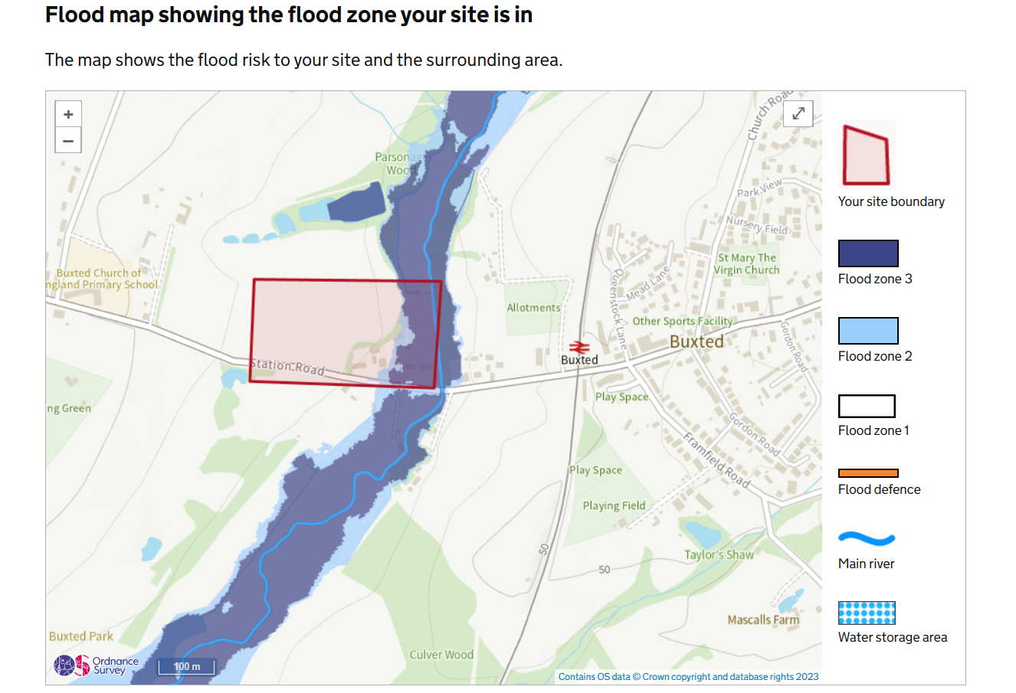

Environmental

Local residents are seriously concerned over the environmental impact this development would have. They regularly see newts, bats, dormice, owls and deer - who spend their summertime living in that field.
There is also much wildlife living in Buxted Park (a site of special scientific interest – SSSI) which would be impacted. There is a very special wildlife corridor that links Buxted Park with the surrounding countryside to the north, where residents frequently see owl, deer and variety of wild birds that nest in hedgerows of the proposed development.
There would be significant light pollution created by the proposed development, to an area which is currently completely dark at night.
Infrastructure

Brookworth Homes statement: ‘We have investigated the school capacity and found it to have space for additional pupils. Doctors’ capacity is a difficult issue to resolve as it is multifaceted. Planning cannot resolve recruitment issues. Not building houses does not ease this burden either as it just prevents households forming. The same number of people still draw on the service. The development will contribute towards infrastructure through CIL payments’.

It is the parish councils opinion that many parishioners would strongly disagree with the above statement. There is already extreme pressure on the local doctor’s surgery.
Action: Could the developer provide evidence from the Local Education Authority as to how many spaces are actually available at the local school.

Power outages, disruption to water supply and overflowing sewage are not uncommon to the current residents of Buxted Parish. An additional 49 dwelling would only compound these issues.

Queries raised by the parish council:

Local services – can the drainage/sewerage system cope given the current state of Southern Water and the lack of proper infrastructure?

Affordable Housing – will the criteria of 35% affordable housing be met? What guarantee do we have that developer won’t later apply to have all open market housing?

Access and Highways – there are already drainage issues on this road which need to be rectified before adding more surface water. The access point at the bottom of the hill is dangerous with poor sight lines and yet the developer estimates that there will be a further 232 additional two-way vehicle trips over a 12-hour period (0700-1900).
Local residents have reported many collisions between lorries at this site (maybe not all reportable to the police), but the additional vehicle movements will exasperate this issue.
The site is situated between Buxted and FAD so everyone will need a car as there are no buses, however the developer states in the Highway document that the Community Transport Scheme bus goes past the site. This is not a regular scheduled bus and gives a false representation of public services.

In pre-app discussions Highways have said (amongst a lot of other things): “It is considered that the existing public footpath on the northern side of the A272 should be widened to a minimum of 1.8m from the site access to The White Hart Buxted, to encourage prospective residents to walk and cycle to local amenities in Buxted.”
Have they given any consideration to the footpath going the other way, the way children would walk to the local school?

Coalescence – removal of strategic gap between settlements. They seem to think that people will walk from Buxted to use the open space on the site!!! I suppose this shows how it will be integrated into Buxted (of course this will never happen) They state:

Concern was expressed that the existing residents of Buxted would be less likely to use the open space associated with the development due to the footpath from the centre of Buxted and the proximity of traffic. The proposal has been amended to incorporate a perimeter footpath around the site which provides a more direct route to the open space and school which is set back away from traffic.

Heritage Setting and attempt at mitigation by the developer.
Noted is a clever attempt at ameliorating the intrusion of this development, or heritage mitigation strategies, (2.6 to 2.12 of Heritage Statement) on the setting of not only the surrounding historic listed buildings, but also a Grade 11 listed park and garden. This development would adversely impact on the following: the setting of Buxted Park and Garden (Grade 11 listed), Harrock House C17 and earlier possible medieval house on same site, Harrock House Lodge (C19) and Hogge House C19, all Grade 11 listed, with the exception of Harrock Lodge. These buildings are mainly all to the south and slightly west of the proposed development. To the east lie Linden House C18, The Old Mill C19, The Mill House C17, once again Grade 11 listed. Then finally the W11 heritage assets in the pill boxes, and anti-tank ditches. There is pill box across the A272 in Buxted Park and another the northern boundary of the development site.
This is a mitigation strategy in an attempt, by the developers, to justify the development under the NPPF section 16 paragraph 200 under a heading ‘Considering potential impacts’: ‘Any harm to, or loss of, the significance of a designate heritage asset (from its alteration or destruction, or from development within its setting), should require clear and convincing justification. Substantial harm or loss of: (a) grade 11 listed buildings, or grade 11 registered parks of gardens, should be exceptional.
Whilst the attempt at opening out a hitherto unavailable historic landscape publically is an interesting mitigation proposal but whether the occupants of Harrock House would be happy viewing the new development is quite another matter. As to turning the western part of the site being put back to its historic character as parkland, this is based solely on the 1878 OS map. In both the Yeakell and Gardner (1778) and the OS Surveyors map (C1820) the surrounding fields are depicted as arable or pasture farmland (figures 1&2). It seems far more likely to be developed in the future if this development, on the eastern side gets planning permission. It is possible that the fishponds are not associated with the Wealden Iron Industry but were developed as fishponds to the earlier, possibly C13, Harrock House and have been re-instated, as such, for a local angling club. The Wealden Iron Industry was centred around the Queenstock furnace to the north-west of the site, sitting alongside the ‘Uckfield Stream’.
Ralph Hogge, who lived in Hogge House took over from William Levett, who cast the first cannon in one piece at Queenstock, and Hogge was a very significant figure in the trade of ordnance. He had a house/farm on the entrance to Buxted Park (Hogge House) which survives today complete with its cast iron rebus of a pig (Hog) over the front doorway.
In the response to Heritage England’s pre-application letter dated 23rd March 2023 (Appendix 1) the Heritage Impact Assessment author is highly critical of Dr Gallo’s findings, but BPC would agree with her comment that:
‘The presence of a housing estate within the currently undeveloped field would introduce a disruptive suburban character to the rural setting of the identified heritage assets, extending the development of Buxted westwards along the A272 and bringing it closer to Buxted Park’.
Buxted Parish Council feels that there has been a total disregard of the contents of this letter/report in an attempt to conform with NPPF policies, as the developer has interpreted them.
However, it wished to point that, in addition to the comments made by Heritage England, that this development will adversely affect the setting of the Grade 11 listed park and garden of Buxted Park, Harrock House and the other listed buildings in the vicinity. The following reasons prove that this development would be quite out of character with its surroundings.
Buxted developed as a linear settlement straggling along a road which did not become an A road until the mid C20. The earliest reference to a lord of the manor in Buxted was in 1279 with a record of two houses near the church in 1354. A map survey dated 1654 shows Buxted Place with its attendant deer park, warren and fields with a few houses grouped around the church. The entrance was via the Lime Tree Avenue. This is directly opposite the proposed new development. In 1725 a new Georgian house was built in the same location as the house today. In the 1812 William Figg map there is only one house near the church. In the 1841 map this is also apparent. Therefore, the village developed further east along the now A272. There was no room or land available to develop within the park itself.
As can be seen from the two following maps, the Yeakell and Gardner (1778) and the 1st edition OS surveyors map of Buxted c1820 shows very scattered ‘dwellings’ or farms along the road. Hogge House is shown within the curtilage of Buxted Place. Harrock House is shown as The Parsonage to the north of Buxted Place. A few buildings are located adjacent to the river, a couple of which the complex of mill building.
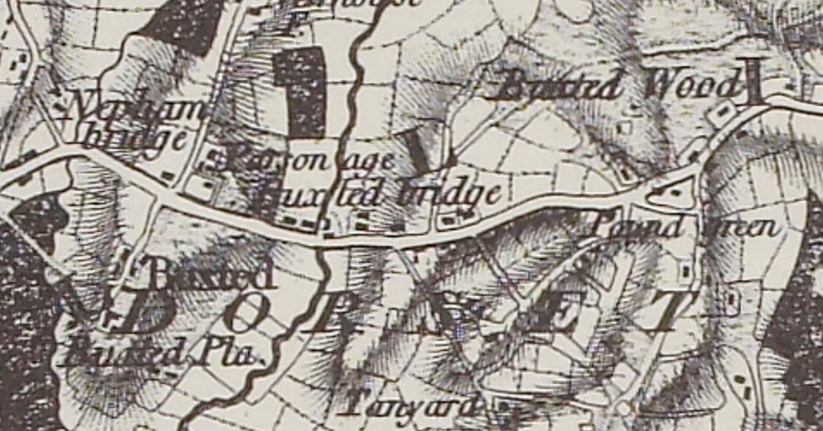
Figure 1
Yeakell and Gardener 1778 ESRO AMS6008
Yeakell and Gardener 1778
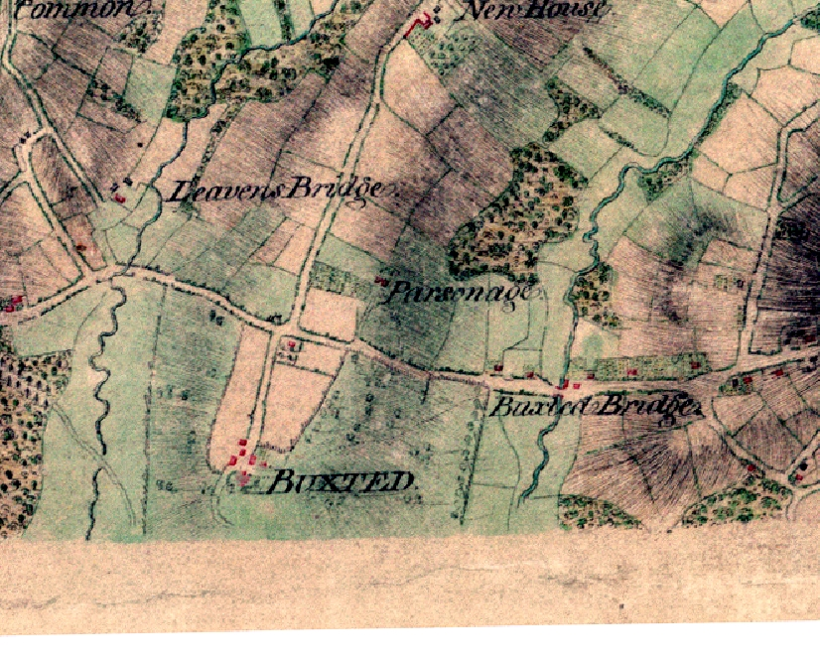
Ordnance Survey Surveyors 1st Edition C1820

Figure 2

It was not until after 1868 with the coming of the railway link from Uckfield to London that Buxted became a village of any size, and the growth was centred mainly east from the station, with some spread north and south from the station. Thereafter, slowly over time, during the mid to latter part of the C20, farms sold off their lands and small housing estates were built such as in Britts Farm. Housing also took over the redundant land which had housed chicken farms, such as Littlewood and Higglers Close. However, the area surrounding and including the potential development site remained untouched with no modern housing, thus retaining the historic rural nature, and setting to Buxted Park, Harrock House, Linden House and the Mill complex. Thus, this is the last part of Buxted to retain its historic landscape setting and it would be a shame to lose this. Also, this would have a detrimental impact on the ecology of this area, further reducing the wildlife corridors. This stretch of road is well known for the deer fatalities which frequently occur along this part of the A72 as it is a crossing point for deer out or into Buxted Park. Road traffic accidents are also exacerbated by flooding along this road and icing in cold weather.
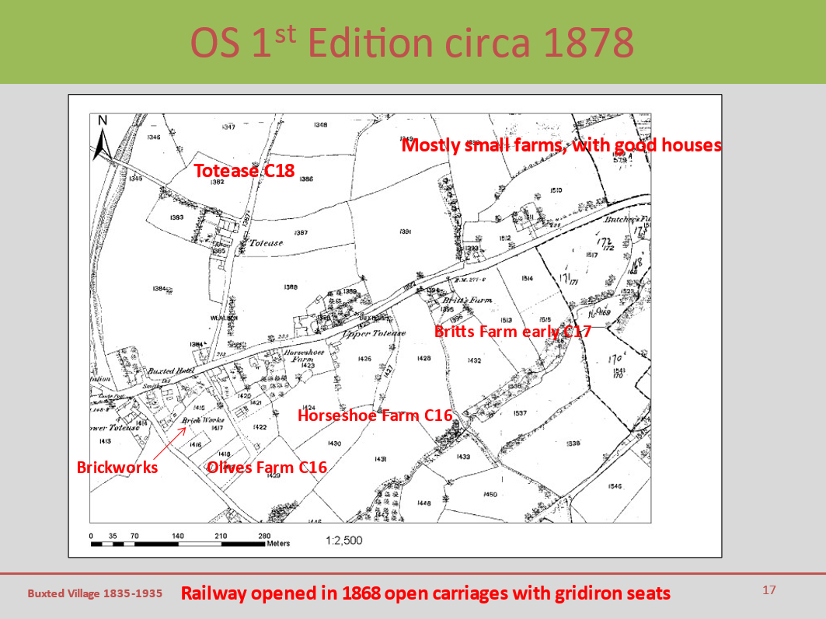
Figure 3
Perhaps the only C20 intrusion into the landscape here are the pill boxes which were part of the Newhaven to Penshurst GHQ stop line. It is suggested in the heritage mitigation strategy that a walk could encompass these pill boxes but, historically they were not intended to be seen, quite the reverse and often they were camouflaged with green and brown paint and one in Buxted had a tiled roof.
The suggestion that one could walk from Buxted Park, cross the A272 into the development site, or vice versa, and continue the proposed perambulation around the development site, has not taken into account just how dangerous crossing the road, in this location would be. Opening up Harrock House to be viewed from the housing estate might benefit the housing estate but would be totally detrimental to the occupants at Harrock House, let alone its historic setting. Moreover, the estate is set lower in the valley than the village of Buxted and the estate would be an unwelcome visual intrusion in the landscape from certain parts of Buxted. This effect would be increased at night with light from the houses.
The insertion of this development is total coalescence, from Buxted to the traffic lights at Coopers Cross, where there is planning permission for a new development, north onto Five Ashdown and south to Ringles Cross. At one time WDC were opposed to any form of coalescence. Is this still not the case? There is a difference in the meaning ‘scattered linear settlement’ as Buxted once was and this attempt to join up the housing along the A272. The proposed design of the new housing in totally out of keeping with the individual historic housing types, which takes the place of many different forms, all age related, and some more use related. Examples of which range from Alms House, Victorian Schools, Mill House and buildings and gentry houses, already mentioned. The new development will always look like a homogenous modern pastiche of older styles instead of individual buildings with their own distinct, unique, and local historic character.
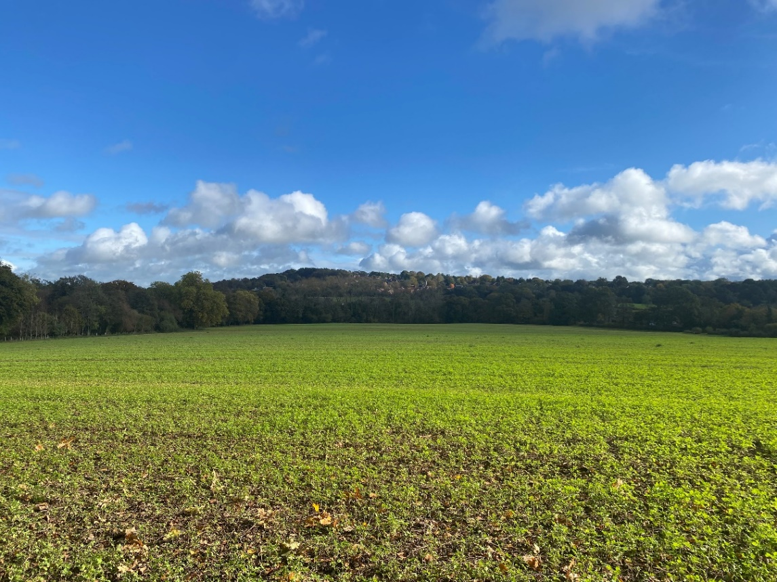
Estate
Buxted village on higher ground
Figure 4

The site was historically used to grow the corn / grain that was stored in The Granary and milled in The Old Mill. The Mill House was where the bread was made and sold to the villagers. In fact, the serving hatch can still be seen on the side of Mill House. According to the documents submitted with the planning application, the Mill Pond has been filled in, but this is not true. The Mill Pond and the Mill Wheel are still very much intact, the Mill Pond water rising and falling with the water table. In 1939, according to historical documentation, an anti – tank ditch blocked the water supply to the Mill Pond as part of WW2 defences. This is further evidenced by the two WW2 Pill Boxes situated on the land proposed for development and adjacent to the Mill Stream.

Conclusion
The site comprises of agricultural fields located to the west of the urban edge of Buxted separated from the settlement by a railway line which currently represents a clear and defining edge to the village of Buxted. Despite the sites proximity to the railway line the site is rural in nature and is isolated from local services and amenities and development would be out of keeping with the surrounding land uses. Development would also have a detrimental impact on the setting of Buxted park and its Grade II* listed park and garden and adjacent listed buildings located to the south of the site.
Referring specifically to the heritage section Buxted Parish Council strongly object to this development on the following grounds:
- That the setting of the various listed assets will be badly compromised
- The experience of interplay between the countryside and the heritage assets would be totally changed and not particularly welcome.
- This area is the final part of the landscape in Buxted which has changed relatively little over a long period of time, that which has been changed has been by natural historic organic development, and it would be a shame to lose this.
- The homogenous nature of a new development would be totally out of place in this landscape setting, where the characteristics of buildings inserted over time is key.
- It is an unacceptable form of coalescence and notwithstanding quite outside the development boundary for Buxted.
- Visual intrusion and light pollution adjacent to heritage assets and from Buxted village itself which sits on the hill, higher than the proposed development.

If the unfortunate decision were to approve the application – we would wish for:
- Widening of pavement to the west to Buxted School
- Site for village hall in ‘Park’ field with parking
- Cast iron guarantee from WDC that they will never have permission to develop the western part of the field further.
- Trees to screen Harrock House from the visual intrusion

ESRO ACC5179/9
Buxted Camouflaged Type 24 | The Pillbox Study Group Website. (pillbox-study-group.org.uk)

